Contents

Short: 1

Context: 1

Part 1: Power Supply 4

Part 2: Act as a switch 5

Part 3: Sense the relay output 7

Part 4: ESP32 and USB 10

Schematics 11

PCB Layout 12

# Short:

This is my first ever electronics project, and these are my main concerns regarding my PCB design sorted by priority:

1. Is this PCB safe to operate with Mains voltage? Any risks you can see?
2. The board is sensing mains (**Part 3** of this document), I added a fuse to the return because it would take too much space to add a fuse for every channel. Is this enough?
3. Are there any other protections that you would add?
4. Is the USB-to-serial correct?
5. Are .250mil traces enough for the USB part?

Full project link: <https://github.com/crgarcia12/electronics-homeassistant-lightscontroll/tree/main/PCB/schematics-v16-espinside/main-project>

# Context:

Most modern houses in Switzerland uses latching relays stored in the central panel turn on/off lights from different switches:

Example DIN latching relay

[(Datasheet)](https://new.abb.com/products/2TAZ352000R2011/e290-16-10-230-60)

I want to control and monitor those lights with an ESP32, for that I will build a DIN rail module that:

1. Act as a switch, controlling the latching relays (Nr 1 in the image)
2. Sense the output of the relays, to check if the lights are ON or OFF (Nr 2 in the image)

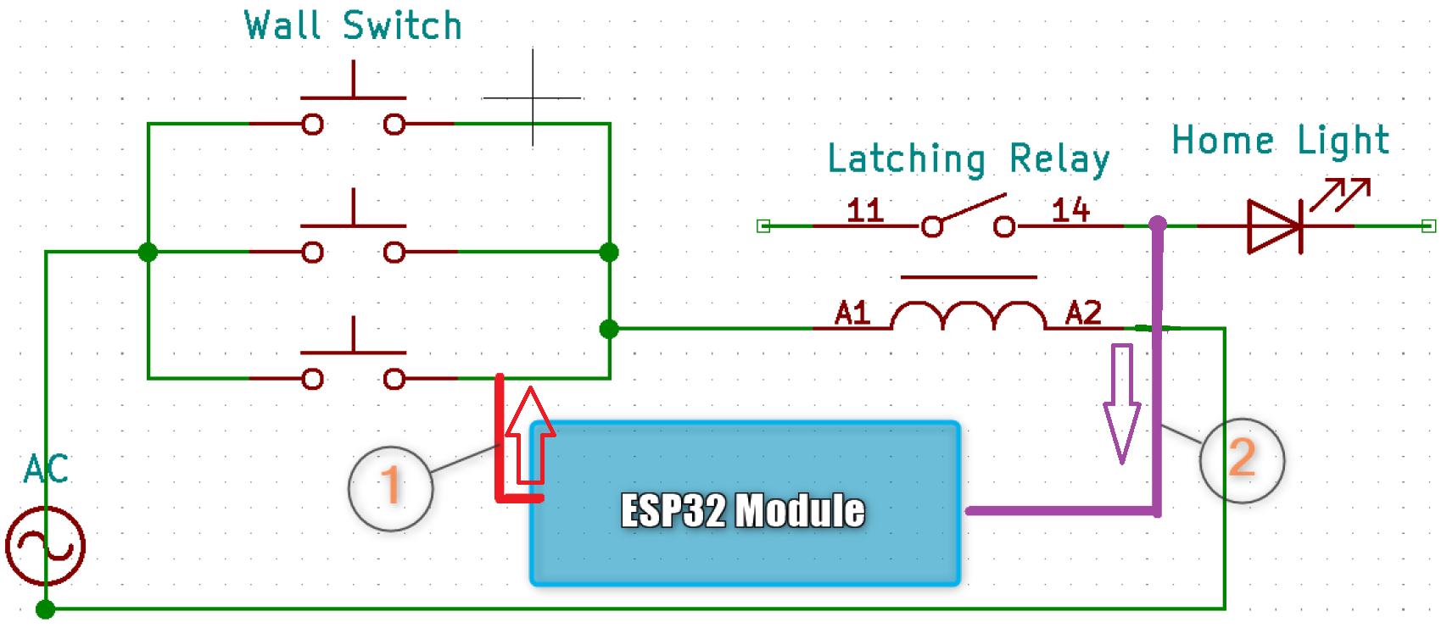

The module can handle four “channels”, so it can control 4 latching relays and sense 4 relays outputs.

The schematics can be split in 4:

1. Power Supply
2. Act as a switch (relays controlled by ESP32) (Nr 1 in the previous image)
3. Sense the relay output (Nr 2 in the previous image)
4. ESP32 + USB

# Part 1: Power Supply

The board 3.3v and 5v, and it needs to be powered with mains. RAC05SK is an AC/DC PowerSupply module

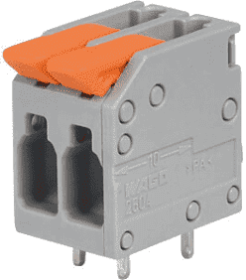

RAC05-05SK datasheet: <https://recom-power.com/pdf/Powerline_AC-DC/RAC05-K.pdf>

# Part 2: Act as a switch

To act as a switch, the module needs to send a short (~50ms) 220V pulse to the input of the latching relays. For that the board will use 4 x 3A relays, and a controller ULN2003A

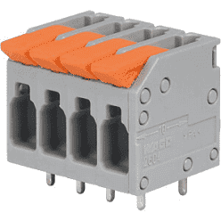

Relay datasheet: <https://www.distrelec.ch/Web/Downloads/_t/ds/PCN_eng_tds.pdf>

ULN2003A datasheet: <https://www.st.com/resource/en/datasheet/uln2001.pdf>

# Part 3: Sense the relay output

Since the lights can be operated manually, the ESP32 needs to know if the house lights are ON or OFF all the time. For that I am planning to sense the output of the latching relay with some resistors and optocouplers:

Note: All EspSensX will have internal pull-up enabled

LDA210 optocoupler: <https://www.ixysic.com/home/pdfs.nsf/www/LDA210.pdf/$file/LDA210.pdf>

I also tried to calculate what would be the optimal resistors value in order they don’t heat up. Considering that the ESP32 pullup resistors are 45k and the optocoupler minimum CTR is 300%:

That sounds way too little current, so I decided to go with 400k instead that gives me 0.57 mA and 13W

# Part 4: ESP32 and USB

Most of the USB part I just copied, I don’t fully understand every detail, and I am not sure if this will actually work because I did not manage to route it nicely.

Some questions:

* What is going to happen when the 3.3v from the PS and from the CP2102 chip collide?
* Are the tracks big enough?
* Would you split this into another stacked board instead?

# Diagram, schematic Description automatically generatedSchematics

# PCB Layout

